

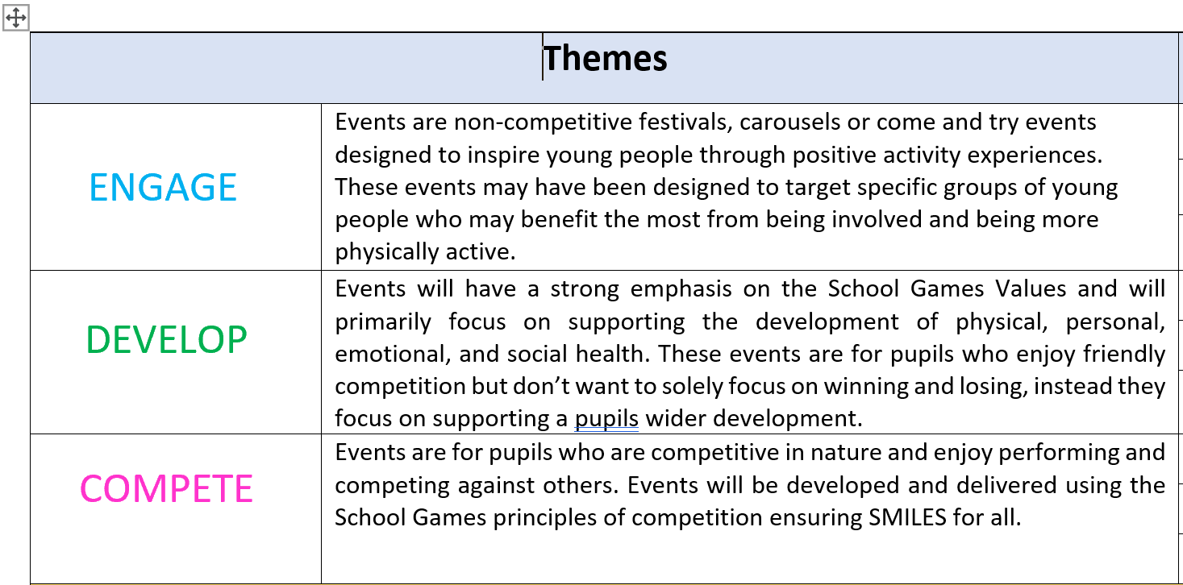
INTENTS

Develop confidence and competence within physical activity/sport skills
Increase regular participation and motivation
Improve knowledge and understanding of sport and physical activity
Build social skills and connections (i.e. sense of belonging)
Championing physical literacy
Improve health and wellbeing (i.e. 60 active minutes)
Engage new/target groups of young people (tackling inequalities)
Provide inclusive opportunities
Create positive experiences
Promote success and achievement
Supporting transition
Develop leadership, character, life skills
Championing youth engagement
To engage/influence wider stakeholders

